AFFIX  YOUR  RECENT  PASSPORT PHOTOGRAPH HERE | 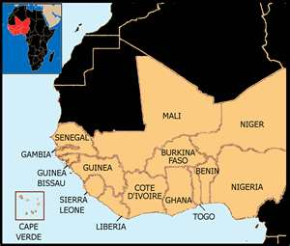  Paediatric Endocrine Training Centre West Africa , Lagos, Nigeria  Steering Committee Members  Prof. Abiola Oduwole Society for Paediatric &  Adolescent Endocrinology  In Nigeria  Ian Hughes European Society for Paediatric  Endocrinology  Dr. Chizo Agwu International Society of  Paediatric and Adolescent  Diabetes  PETCWA  PAEDIATRIC ENDOCRINE  TRAINING CENTRE  WEST AFRICA

PART ONE: Personal Information
Please tell us a little more about yourself here:

Full Name *
First Name Other Names Last Name
Date of Birth *
Day Month Year
Marital Status *

Citizenship *
Passport Number Expiry Date
E-mail *

Address *
Line 1

Line 2

City State

Postal Country
Phone Number (s) *
Area code Phone Number

Area Code Phone Number

PART TWO: Next of Kin (Contact in Case of Emergency)
Full Name *
First Name Other Names Last Name
Relationship *

Address *

City State
Phone Number *
Area code Phone Number
E-mail *

PART THREE: Additional Documentation
To make sure your application is complete, please be sure to provide the following information:

Name of two Academic Referees *

University Education and Qualifications obtained
Medical degree*
University attended*
Date*
Started Ended
Field of Study *
Paediatric Training *
Other Degrees and Diplomas (where applicable) *
State Qualifying practical experience in Paediatrics *

Indicate ability to raise International Medical insurance cover *
Name and Address of current Employer *
_{Name}

_{Address}

_{Address}
I certify that the information I have provided is correct *
_{Name}

Signature Date

Attachments Required:
- Curriculum Vitae
- Two letters of recommendation
- Degrees and Diplomas in Paediatrics
- Others if applicable

